MSSE – I –Advanced Data Mining

**Submitted To: Dr. Raheel Zafar**

**Submitted By: Uzair Javed**

**Class ID: NUML-F21-12331**

**Date: 01 December 2021**

( Assignment 2 )

# What is deep learning in conventional neural network (CNN)?

Deep Learning is an area of machine learning that deals with artificial neural networks, which are algorithms inspired by the structure and function of the brain.Deep learning is a key technology behind driverless cars, enabling them to recognize a stop sign, or to distinguish a pedestrian from a lamppost. It is the key to voice control in consumer devices like phones, tablets, TVs, and hands-free speakers. Deep learning is getting lots of attention lately and for good reason. It’s achieving results that were not possible before.

In deep learning, a computer model learns to perform classification tasks directly from images, text, or sound. Deep learning models can achieve state-of-the-art accuracy, sometimes exceeding human-level performance. Models are trained by using a large set of labeled data and neural network architectures that contain many layers.

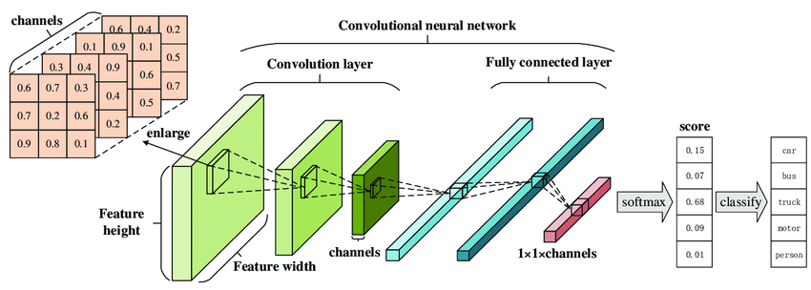

# How does deep learning attain such impressive results?

In a word, accuracy. Deep learning achieves recognition accuracy at higher levels than ever before. This helps consumer electronics meet user expectations, and it is crucial for safety-critical applications like driverless cars. Recent advances in deep learning have improved to the point where deep learning outperforms humans in some tasks like classifying objects in images.

While deep learning was first theorized in the 1980s, there are two main reasons it has only recently become useful:

1. Deep learning requires large amounts of labeled data. For example, driverless car development requires millions of images and thousands of hours of video.
2. Deep learning requires substantial computing power. High-performance GPUs have a parallel architecture that is efficient for deep learning. When combined with clusters or cloud computing, this enables development teams to reduce training time for a deep learning network from weeks to hours or less.

# Examples of Deep Learning at Work:

Deep learning applications are used in Automated driving, Aerospace, Defense, Medical, Research, Industrial Automation and Electronics.

# How Deep Learning Works

Most deep learning methods use [neural network](https://www.mathworks.com/discovery/neural-network.html) architectures, which is why deep learning models are often referred to as deep neural networks.

The term “deep” usually refers to the number of hidden layers in the neural network. [Traditional](https://www.mathworks.com/videos/getting-started-with-neural-networks-using-matlab-1591081815576.html) [neural networks](https://www.mathworks.com/videos/getting-started-with-neural-networks-using-matlab-1591081815576.html) only contain 2-3 hidden layers, while deep networks can have as many as 150.

Deep learning models are trained by using large sets of labeled data and neural network architectures that learn features directly from the data without the need

Deep Learning which has emerged as an effective tool for analyzing big data – uses complex algorithms and artificial neural networks to train machines/computers so that they can learn from experience, classify and recognize data/images just like a human brain does. Within Deep Learning, a Convolutional Neural Network or CNN is a type of artificial neural network, which is widely used for image/object recognition and classification. Deep Learning thus recognizes objects in an image by using a CNN. CNNs are playing a major role in diverse tasks/functions like image processing problems, computer vision tasks like localization and segmentation, video analysis, to recognize obstacles in self-driving cars, as well as speech recognition in natural language processing. As CNNs are playing a significant role in these fast-growing and emerging areas, they are very popular in Deep Learning.

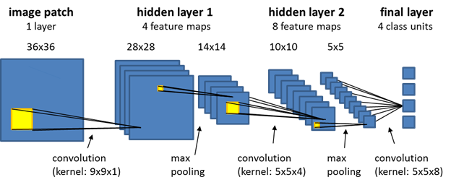

* CNNs have fundamentally changed our approach towards image recognition as they can detect patterns and make sense of them. They are considered the most effective architecture for image classification, retrieval and detection tasks as the accuracy of their results is very high.
* They have broad applications in real-world tests, where they produce high-quality results and can do a good job of localizing and identifying where in an image a person/car/bird, etc., are. This aspect has made them the go-to method for predictions involving any image as an input.
* A critical feature of CNNs is their ability to achieve ‘spatial invariance’, which implies that they can learn to recognize and extract image features anywhere in the image. There is no need for manual extraction as CNNs learn features by themselves from the image/data and perform extraction directly from images. This makes CNNs a potent tool within Deep Learning for getting accurate results.
* According to the paper published in ‘Neural Computation’, “the purpose of the pooling layers is to reduce the spatial resolution of the feature maps and thus achieve spatial invariance to input distortions and translations.” As the pooling layer brings down the number of parameters needed to process the image, processing becomes faster even as it reduces memory requirement and computational cost.
* While image analysis has been the most widespread use of CNNs, they can also be used for other data analysis and classification problems. Therefore, they can be applied across a diverse range of sectors to get precise results, covering critical aspects like face recognition, video classification, street/traffic sign recognition, classification of galaxy and interpretation and diagnosis/analysis of medical images, among others.